Test # 185
Instrument Name Consistometer
Instrument Type Consistometer
Test Start 19/02/01 10:52
Test Stop 2:44:54
Well ID # Unidentified
Customer KOGALYM-LUKOIL AIK
Cement Class G
Additives 1.1%TDF-1+Defoamer
Cement Mfr DYKERHOFF
BHCT 55
BHST 55
Density 1900
Fluid Loss
Job Type 146 MM CSG HESITATION SQUEEZE
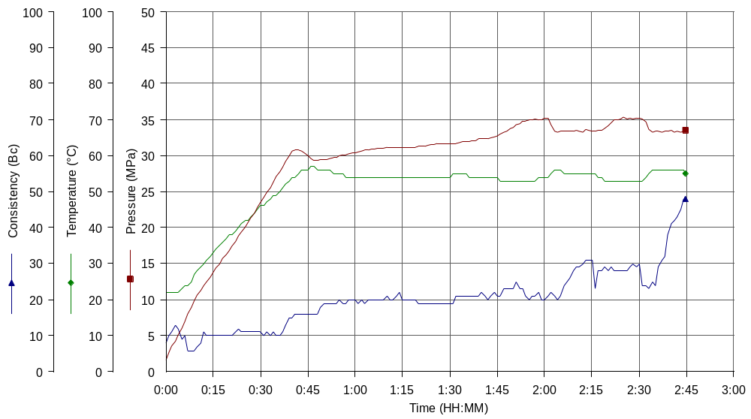
Comments MPa: 28.9(40.2min), 33.3(80.5min); T: 55(40.2min); Standard API Hesitation Squeeze Cycle

